**MUSIC BLOG**

**4th B. TECH 1ST-SEM (Computer Science & Engineering)**

**Submitted by:**

**KAVALI SWETHA SREE 20AP1A0527**

**OLETI NIKHITHA 20AP1A0535**

**PALA KOMALA DEVI 20AP1A0537**

**SURISETTI BHAGYA LAKSHMI 20AP1A0543**

**Under the supervision of**

MR.R.MADHUSUDAN RAO



**DEPARTMENT OF COMPUTER SCEIENCE AND ENGINEERING**

**BHIMAVARAM INSTITUTE OF ENGINEERING&TECHNOLOGY**

**PENNADA-534243, ANDHRA PRADESH**

**BATCH 2020-2024**

**CERTIFICATE**

This is to certify that the dissertation entitled **“Music Blog”** that is being submitted by our team SURISETTI BHAGYA LAKSHMI (20AP1A0543), OLETI NIKHITHA (20AP1A0535), KAVALI SWETHA SREE (20AP1A0527), PALA KOMALA DEVI (20AP1A0537).

In partial fulfilment for the award of **Bachelor of Technology in Computer Science and Engineering to the College of Bhimavaram** **Institution Of Engineering and Technology, Bhimavaram , Jawaharlal Nehru Technological university, Kakinada** is a record of bonafide work carried out by the mundermy guidance and supervision.

The results embedded in this dissertation have not been submitted to any other university/institute for the award of any degree/diploma. -

INTERNAL GUIDE Head of Department

MR.R.MADHUSUDAN RAO MR.U.S.V.VINOD

Assistant Professor Associate Professor

Department of CSE Department of CSE

**DECLARATION**

I hereby declare that the entitled with “building blog entitled with music blog” is submitted by our team. I thank “MR.U.S.V.VINOD HOD of CSE and all the staff members who have encouraged and motivated me to complete the project. The project entitled ”building blog entitled with MUSIC BLOG” is the work done under the guidance of MR.R.MADHUSUDAN RAO, Bhimavaram institute of engineering and technology, Bhimavaram.

IV B. Tech - I Sem - CSE

Batch:2020-24

**Date:**

**Place:**

**ACKNOWLEDGEMENT**

In the accomplishment of this project successfully, many people have best owned upon me their blessings and the heart pledged support, this time I am utilizing to thank all the people who have been concerned with this project.

I would like to thank my **guide and project coordinator**, whose valuable guidance has been the ones that helped me to patch this project and make it full proof success.

I would like to thank my **principal Dr. K. Suresh, Bhimavaram Institute of Engineering and Technology College**, whose encouragement and guidance helped me for the fulfillment of the project

Then I would like to thank my **Head of the Department CSE Mr. U.S.V.Vinod, faculty and management of college**, who have helped me with their valuable suggestions and guidance has been very helpful in various phases of the completion of the project.

Last but not the least I would like to thank my classmates who have helped me a lot.

By: S.BHAGYA LAKSHMI

O.NIKHITHA

K.SWETHA SREE

P.KOMALA DEVI

**ABSTRACT**

Blog is a communication tool that plays a key role in a web application. Use of blogs has resulted in a paradigm shift in the way a web application interacts with the customer. During the development of web applications, there is a need to elicit and specify the requirements for the blogging functionality. In this study, we present a requirements checklist for the blog, from the perspective of integrating the blog in a web application. We follow the use case based approach for identifying the software requirement for the blog. The requirement checklist helps both the web application and the developer during the requirement elicitation of the blog’s software. The checklist is also useful during the testing phase for the validation and verification of the blog functionality.

# 

|  |  |  |
| --- | --- | --- |
| **S.NO** | **TITLES** | **PAGE NO** |
| **01** | **INTRODUCTION**  1.1Overall Description  1.2Purpose  1.3 functionalities  1.4 Features |  |
| **02** | **REQUIREMENTS**  2.1Software  Requirements  2.2Hardware  Requirements |  |
| **03** | **BENEFITS OF BLOG APP**  3.1Advantages  3.2Disadvantages |  |
| **04** | **USECASE DIAGRAMS**  4.1Registration form  4.2Login page |  |
| **05** | **CODE REFRENCES**  5.1Home.html  5.2 Registration.html  5.3Registration.css  5.4Login.html  5.5Main.html  5.6Main.css  5.6.1Telugu.html  5.6.2Hindi.html  5.6.3English.html |  |
| **06** | **CONCLUSION** |  |

**1.INTRODUCTION:**

Blog is an important social networking tool included in a web application, to facilitate interaction and collaboration with the users. For a web application, it is an important part of online marketing. Blog in a web application is used for promoting products and services, writing articles, providing product updates, educating user. Blog facilitates communication and interaction with the user to share knowledge and expertise. Generally, the second option of installing blog software in own server space is the preferred choice of a web application. It is not a standard practice to write code for the blog.

**1.1 Overall Description**

The main aim of this application is to provide a hassle-free accessing of the posted blogs, entries, topics etc. It also used for posting the blogs, editing the blogs, deleting the posted blogs etc. It is also used for viewing and posting the others one9s blogs/posts.

Every organization, whether big or small, has challenges to overcome and managing the information of Idea, Blogs, Entries, Content, Views. Every Online Blogging System has different blogs needs therefore we design exclusive employee management systems that are adapted to your managerial requirement.

## 1.2 Purpose

The purpose of a blog is to create a more engaging website for your brand. Along with using your website to teach users about your products and services, you can also include a blog section to teach consumers about topics that are relevant to your field. Along with this, a blog can help you get more website traffic from search engines. By incorporating relevant keywords, more people can find your blog posts through search and potentially find the rest of your website.

**1.2.1 Functionalities provided by Blog app as follows:**

## 1. Ease of Use

First, any blog content management system has to be easy to use. No blogger wants to spend hours just trying to figure out how to create a blog post or add a tag.

## 2. Support from Real People

The best website teams provide help that's just a phone call or email away.

**3. A Really Good Content Editor**

The ability to format blog content the way you want to see it without needing to know HTML or other programming languages is essential.

**4. Ability to Manage Many Bloggers**

It is important to maintain a consistent message throughout your blog posts. LRS Antilles, as the content management system, provides a rich [**user management.**](https://www.lrswebsolutions.com/Blog/Posts/83/Antilles-Pro/2020/1/How-to-Use-Insider-Roles-in-LRS-Antilles-CMS/blog-post/)

**5. Share**

The whole point of a blog post is to have as many people read as possible. If blog readers can easily share, your content will be seen by the people in their network, extending your reach exponentially.

### 6. SEO

SEO stands for Search Engine Optimization. Basically, it's making sure your website pages show up when users run a search on your topic keywords.

**Features** **provided by Blog app as follows:**

1. **User Authentication and Profiles:**  Allow users to create accounts, log in, and have their own profiles. This can enable personalized experiences, such as saved favorite posts, commenting, and user-specific recommendations.
2. **Search Functionality:** Implement a robust search feature that lets users easily find specific blog posts based on keywords or categories.
3. **Tagging and Categories:** Organize your blog posts into categories or tags, making it easier for users to discover related content.
4. **Pagination or Infinite Scroll:** If you have a large number of blog posts, implement pagination or infinite scroll to improve user experience when browsing through posts.
5. **Social Sharing Buttons:** Allow users to easily share your blog posts on social media platforms to increase visibility and reach.
6. **Related Posts:** Display related posts at the end of each article to keep users engaged and encourage them to explore more content.
7. **Featured Posts or Slideshow:** Showcase featured or popular posts using a slideshow or carousel on the homepage.
8. **Commenting System:** Implement a robust commenting system that allows users to leave comments, reply to others, and upvote or downvote comments.
9. **Email Newsletter Subscription:** Allow users to subscribe to your blog's newsletter to receive updates about new posts and other relevant information.
10. **Analytics Integration:** Integrate tools like Google Analytics to track user engagement, traffic sources, and other important metrics.
11. **Interactive Elements:**  Incorporate interactive elements like quizzes, polls, or surveys within your blog posts to increase user engagement.
12. **Multi-Author Support:** If you plan to have multiple authors contributing to the blog, implement a system that allows each author to have their own profile and display their posts.
13. **Content Scheduling:** Add a content management system (CMS) that enables you to schedule posts for future publication.
14. **RSS Feed:** Provide an RSS feed for users who want to subscribe to your blog's updates using feed readers.

**15.Accessibility Features:** Ensure your blog is accessible to users with disabilities by incorporating accessibility features and adhering to best practices.

**16.Monetization Options:** If you're interested in monetizing your blog, consider integrating advertising banners, affiliate links, or even a premium subscription model.

**2. REQUIREMENTS AS FOLLOWS**

# 2.1Software Requirements

* Text Editor: Any code editor like Visual Studio Code, Sublime Text, Atom, or Notepad++.
* Web Browser: Chrome, Firefox, Safari, or Edge for testing and viewing your web pages.
* Code Version Control: Optional but recommended for collaborative work, you can use Git with platforms like GitHub or GitLab.
* Local Development Server: You can use tools like Live Server for real-time preview of your changes.
* **Graphics Software (Optional):** If your entertainment application involves graphic design or image manipulation, you might need graphic design software like Adobe Photoshop, GIMP, or Canva.
* **Frameworks and Libraries:** Depending on your specific entertainment project, you might consider using front-end libraries and frameworks such as React, Vue.js, or Angular to simplify development and enhance user interaction.

**2.2 Hardware Requirements**

* Computer: A desktop or laptop with a compatible operating system (Windows, macOS, Linux).

* Internet Connection: Needed for online resources, libraries, and testing in a browser.
* **Monitor and Display:** A larger monitor or dual-monitor setup can be helpful for designing and developing your web application, allowing you to view code, design, and browser previews simultaneously.
* **Input Devices:** A keyboard and mouse are the primary input devices used for coding and designing. Additionally, a drawing tablet might be useful if your entertainment application involves any graphic design or drawing elements.

**3.BENEFITS OF BLOG APP**

**3.1 Advantages**

* Blog Brings Traffic to Your Website.

* Music makes you happier.

* Helps you Generate More Leads and Conversions.

* It helps in enhances running performance.

* Helps you Repurpose Content for Other Marketing Channels.

* Music improves health and lowers stress.

* Helps you Build Authority in Your Industry.

* Entertainment reduces depression

* Helps You Strengthen Brand Recognition.

* It gains strengthens learning and memory.

* Helps You Build an Engaging Audience.

**3.2 Disadvantages**

* You may invest time, sweat and soul and get nothing in return.

## It can trigger bad memories

* It takes a huge upfront investment of time and work.

* Music can be distracting.

* It's a lot more difficult than it looks.

* It’s very difficult to make money in the music industry

* It causes noise pollution.

* Blogging for your business can actually hurt you if you do it wrong.

* Making Bad Decisions.

* Blogging while traveling full-time isn’t a small tasks.

* Music can be distracting

**USECASE DIAGRAMS:**

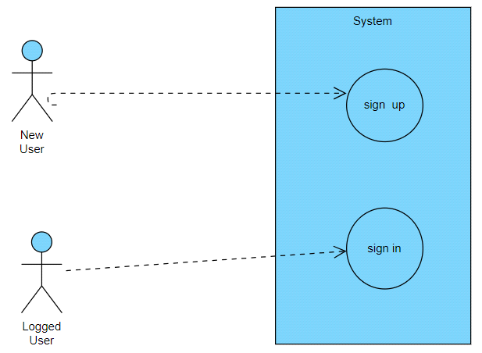

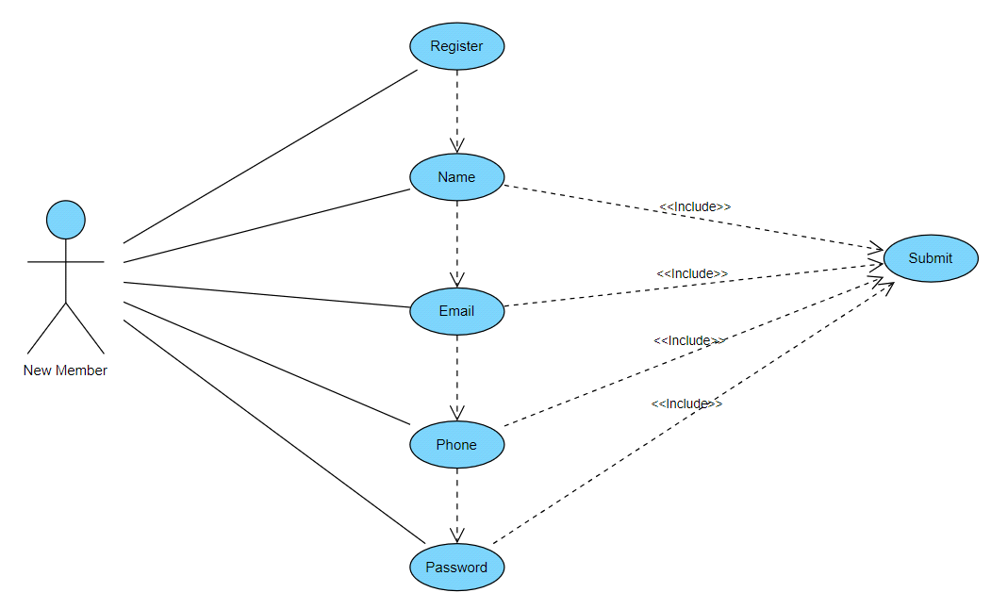**Registration Form**

**Login Form**

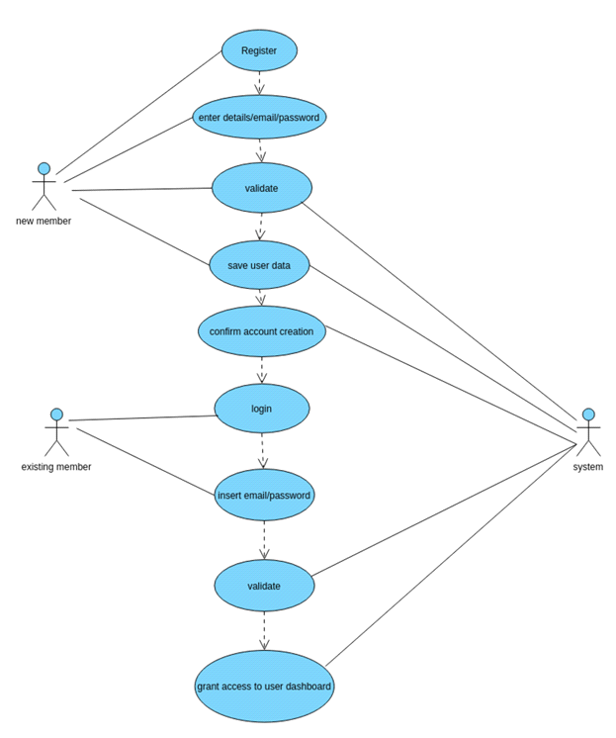

**5.CODE REFERENCES:**

**5.1HOME PAGE:**

<html>

<head>

<meta charset="UTF-8">

<meta http-equiv="X-UA-Compatible" content="IE=edge">

<meta name="viewport" content="width=device-width, initial-scale=1.0">

<title>Blog : Homepage</title>

<link href="https://fonts.googleapis.com/css2?family=Poppins:ital,wght@0,400;0,500;0,600;1,600&display=swap" rel="stylesheet">

<link rel="stylesheet" href="home.css">

<style>

button {

background: #fff;

/color: #000000;/

font-weight: 600;

border: none;

padding: 12px 20px;

cursor: pointer;

border-radius: 20px;

font-size: 28px;

border: 2px solid transparent;

transition: 0.3s ease;

}

button:hover {

color: #fff;

border-color: #fff;

background: rgba(255, 255, 255, 0.15);

}

</style>

<nav class="navbar">

<style>

body {

background-image: url('home.jpg');

background-size: 1550px 850px;

background-position: center;

background-attachment: fixed;

background-repeat: no-repeat;

}

#one{

padding-left: 60px;

padding-top: 60px;

}

#two{

padding-left: 300px;

}

</style>

</head>

<body>

<div id="one">

<p style="color:rgb(21, 37, 25);font-size:60px;">Welcome To The Music World</p>

</div>

<style>

body {

background-image: url('media_imagegs/home.jpg');

background-size: 1550px 850px;

background-repeat: no-repeat;

}

</style>

</nav>

<header class="header">

<div class="content">

</h1>

<div id="two">

<button class="button"><a href="REGISTRATION.HTML">Sign up</a></button>

&nbsp;&nbsp; &nbsp;&nbsp; &nbsp;&nbsp;&nbsp;&nbsp; &nbsp;&nbsp; &nbsp;&nbsp;

<button class="button"><a href="login.html">Sign in</a></button>

</header>

</div>

</body>

</html>

**OUTPUT:**

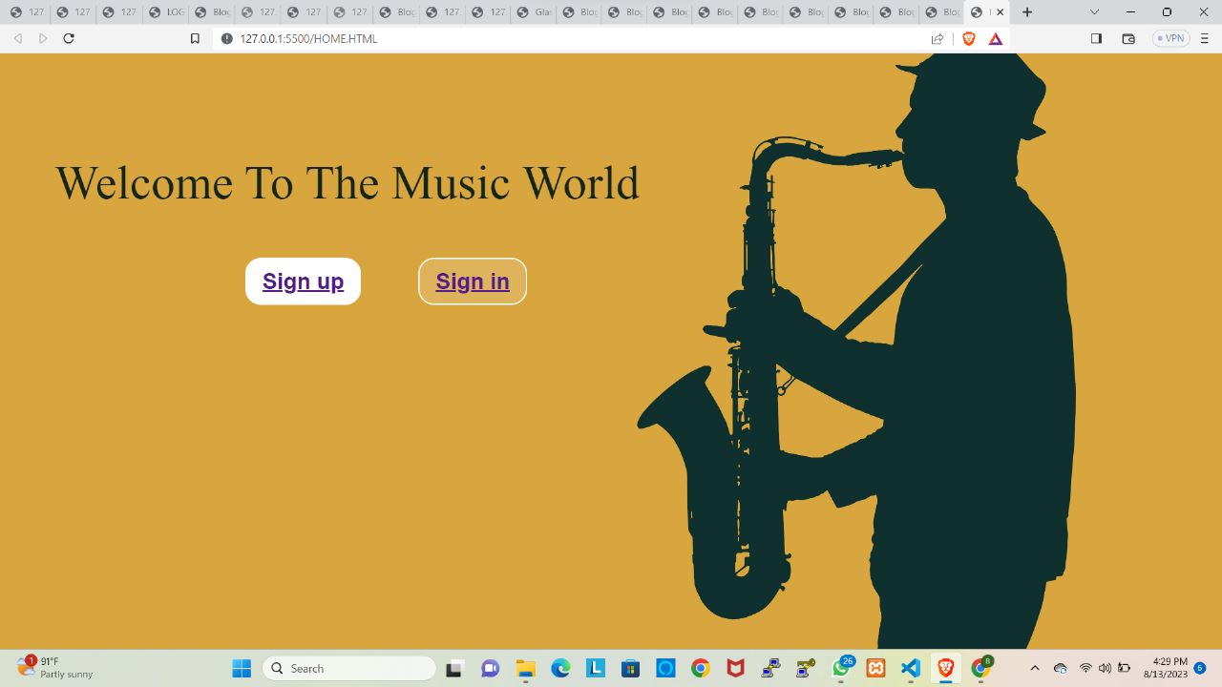

**6.CONCLUSION**

A blog summary is a vital aspect of the content. It can accompany your primary text on many platforms online, and it can be an important draw for your target audience. So, if you wish to promote your content on social media, then a summary is the most important glimpse of your main content.